**עבודה בפייתון**

תשובות:

1. Both printHello() and a refer to the same object.
2. a = 20
3. A class is blueprint for the object.
4. Java
5. This function is called when a new object is instantiated.
6. 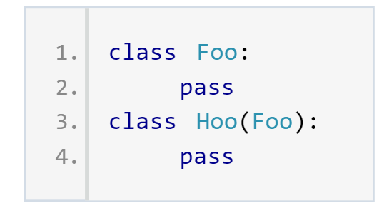1 1
8. Multiple Inheritance
9. All of the above.
10. 4 6